PROJECT REPORT
Data Preprocessing of the Algerian Forest Fires Dataset
Cleaning, validation and exploratory inspection using Python
Notebook: preprocessing.ipynb | Language: Python 3.12 | Date: 13 October 2026

1. Introduction
Forest fires cause serious ecological and economic damage, and predicting when fire-prone conditions occur is a classic machine-learning problem. This project prepares the Algerian Forest Fires dataset for a downstream binary classification task: given daily weather observations and fire-weather indices, predict whether a fire occurred (fire) or not (not fire).
The raw CSV file is not directly usable. Two regional tables are stacked inside a single file, with a title row, a repeated header row and blank separator rows in between. Column names carry stray whitespace, every numeric column is stored as text, and the class label appears in several inconsistently padded spellings. The work documented here turns that raw file into a clean, fully numeric, analysis-ready dataset and then inspects the result with range checks, box plots and histograms.

1.1 Objectives
- Load the raw file and inspect its structure to locate formatting problems.
- Label each observation with the region it belongs to.
- Standardise column names and the target labels.
- Check for duplicates and handle missing or corrupt records.
- Convert all measurement columns to numeric types.
- Validate value ranges and inspect outliers and distributions.
- Export the cleaned data as clean_dataset.csv for modelling.

2. Tools and Environment
All work was carried out in a Jupyter notebook running Python 3.12 in a virtual environment. The libraries used were pandas for loading, cleaning and type conversion, NumPy for numeric support, and Matplotlib with Seaborn for visualisation. Cleaned output is written with DataFrame.to_csv.

3. Dataset Description
The source file (Dataset/Algerian_forest_fires_dataset.csv) contains daily records from June to September 2012 for two regions of Algeria. The first block of rows belongs to one region (the Bejaia region in the public UCI version of this dataset) and the second block, introduced by the title row "Sidi-Bel Abbes Region Dataset", belongs to the Sidi-Bel Abbes region. Each block holds 122 daily observations, giving 244 genuine records. Together with three non-data rows (one blank, one title, one repeated header) the file has 247 rows. Table 1 lists the variables.

Variable | Group | Description
day, month, year | Date | Calendar date of the observation (June to September 2012).
Temperature | Weather | Noon temperature in degrees Celsius.
RH | Weather | Relative humidity (%).
Ws | Weather | Wind speed (km/h).
Rain | Weather | Total rainfall for the day (mm).
FFMC | FWI system | Fine Fuel Moisture Code: moisture of litter and fine surface fuels.
DMC | FWI system | Duff Moisture Code: moisture of loosely compacted organic layers.
DC | FWI system | Drought Code: long-term dryness of deep organic layers.
ISI | FWI system | Initial Spread Index: expected rate of fire spread.
BUI | FWI system | Buildup Index: total fuel available for combustion.
FWI | FWI system | Fire Weather Index: overall fire intensity rating.
Classes | Target | Fire occurrence: fire or not fire (encoded as 1 and 0).
region | Engineered | Region identifier added in preprocessing (0 or 1).
Table 1. Variables in the dataset. The FWI-system columns come from the Canadian Fire Weather Index system.

4. Preprocessing Methodology
The notebook follows a deliberate inspect-then-fix workflow. Each step below states what was observed, what was done and why.

4.1 Loading and initial inspection
The CSV was loaded with pd.read_csv. Printing rows 120 to 130 immediately revealed the structural problems: after the last row of the first region (row 121) came an empty row (122), the title row "Sidi-Bel Abbes Region Dataset" (123) and a second copy of the column header (124), followed by the data of the second region. Calling describe(include='all') confirmed that every column was treated as text, since mean, standard deviation and quartiles were all undefined, and that the Classes column had nine distinct values for what should be a two-class variable.
df = pd.read_csv('Dataset/Algerian_forest_fires_dataset.csv')
df.loc[120:130] # reveals the separator, title and header rows
df.describe(include='all') # shows all columns are non-numeric

4.2 Region labelling
Because the two regions are stacked in one file, the region information would be lost once the title row is removed. A new column region was created before any cleaning: rows up to the separator were assigned 0 and the rows from the separator onward were assigned 1. This preserves a potentially useful grouping feature, since the two regions may differ in climate and fire behaviour.
df.loc[:122, 'region'] = 0
df.loc[122:, 'region'] = 1

4.3 Column-name standardisation
Several headers contained leading or trailing spaces (for example ' RH', ' Ws', 'Rain ' and 'Classes '), which makes column access error-prone. All names were stripped in one step.
df.columns = df.columns.str.strip()

4.4 Duplicate check
df.duplicated().sum() returned 0, so no exact duplicate rows were present and drop_duplicates() removed nothing. The check is cheap insurance when several files are concatenated, as they are here.

4.5 Data-type conversion
Every feature column had been read as a string. The cause is the repeated header row sitting in the middle of the data: a single text value such as 'Temperature' forces the whole column to a text type. Unique-value listings confirmed this (for example the month column contained the strings 'month' and 'year' alongside the real numbers). The columns were converted with pd.to_numeric(errors='coerce'), which parses valid numbers and turns anything unparseable into NaN. This was tried on Temperature first, verified, and then applied to all thirteen date and measurement columns.
num_cols = ['day','month','year','Temperature','RH','Ws','Rain',
'FFMC','DMC','DC','ISI','BUI','FWI']
df[num_cols] = df[num_cols].apply(pd.to_numeric, errors='coerce')

4.6 Handling missing and corrupt records
Before conversion, the missing-value count was one to three per column, with Classes at 1.2% and the date and weather columns at 0.8%. After conversion the count rose to three or four per column, because coercion exposed values that had been hiding as text. Filtering for rows containing any NaN isolated exactly four records (Table 2).

Row | What it is | Evidence | Action
122 | Blank separator row | All fields empty | Removed
123 | Region title row | Text in first column, all others empty | Removed
124 | Repeated header row | Header text in every column; coerced to NaN | Removed
168 | Corrupt observation | Valid date and weather, but DC and FWI unparseable | Removed
Table 2. The four incomplete records identified after numeric conversion.
dropna() removed these four rows, which is 1.6% of the file. Three of them contain no data at all, so there is nothing to impute. Row 168 held real measurements, but two of its fields could not be recovered from the file, so it was dropped rather than filled with an estimate. The index was then reset so row labels run from 0 to 242.
df[df.isnull().any(axis=1)] # inspect the four problem rows
df.dropna(inplace=True)
df.reset_index(drop=True, inplace=True)

4.7 Target-label encoding
After cleaning, the Classes column still contained eight spellings of two labels, differing only in trailing spaces ('fire', 'fire ', 'fire ', 'not fire', 'not fire ', and so on). The text was stripped and mapped to integers: not fire became 0 and fire became 1. The resulting column has dtype int64, which confirms that every label was mapped and no new missing values were introduced.
df['Classes'] = df['Classes'].str.strip()
df['Classes'] = df['Classes'].map({'not fire': 0, 'fire': 1})

5. Results

5.1 Summary of the cleaning
Table 3 compares the dataset before and after preprocessing.

Aspect | Raw file | Cleaned dataset
Rows | 247 | 243
Columns | 14 | 15 (adds region)
Non-data rows (blank, title, header) | 3 | 0
Incomplete records | 1 (row 168) | 0
Missing values | Present | 0
Duplicate rows | 0 | 0
Numeric measurement columns | 0 of 13 (all text) | 13 of 13 (float64)
Distinct Classes values | 9 (including header text) | 2 (0 and 1)
Records per region | Not labelled | 122 (region 0) and 121 (region 1)
Table 3. Dataset before and after preprocessing.

5.2 Range validation
After conversion, the minimum and maximum of every column were checked for impossible values. The date columns are consistent: days run from 1 to 31, months from 6 to 9 and the year is always 2012. The weather and index columns (Table 4) all fall within physically sensible limits, so no value was flagged as an entry error.

Feature | Minimum | Maximum | Feature | Minimum | Maximum
Temperature (°C) | 22.0 | 42.0 | DMC | 0.7 | 65.9
RH (%) | 21.0 | 90.0 | DC | 6.9 | 220.4
Ws (km/h) | 6.0 | 29.0 | ISI | 0.0 | 19.0
Rain (mm) | 0.0 | 16.8 | BUI | 1.1 | 68.0
FFMC | 28.6 | 96.0 | FWI | 0.0 | 31.1
Table 4. Minimum and maximum values of the weather variables and fire-weather indices after cleaning.

5.3 Outlier analysis
Box plots were drawn for every column to look for extreme values. Figures 1 and 2 show the ten continuous features; the date columns, region and the binary label carry no useful information in a box plot.
Among the weather variables (Figure 1), Temperature and RH are fairly symmetric, with at most a single low-end outlier for temperature. Ws shows a few high and low outliers around a tight core of 14 to 17 km/h. Rain is the most extreme case: the median and most of the box sit at or near zero, with a long tail of wet days reaching 16.8 mm, so many points are flagged as outliers.
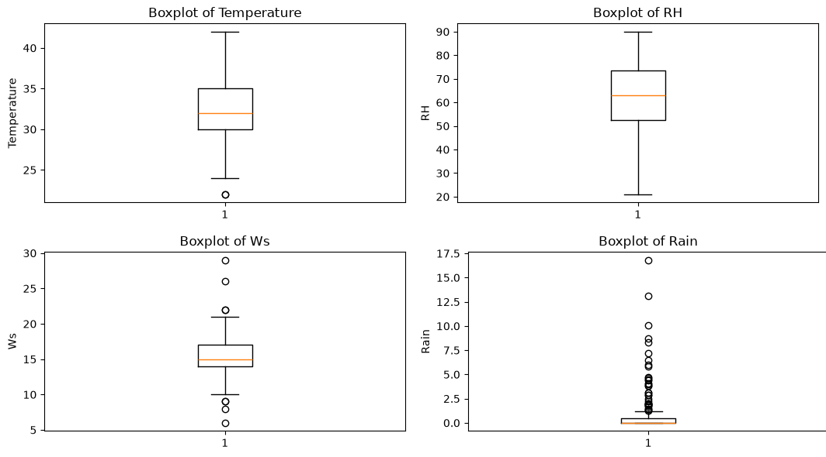
Figure 1. Box plots of the weather variables (Temperature, RH, Ws, Rain).
The fire-weather indices (Figure 2) show a clear pattern. FFMC is skewed the other way, with its outliers at the low end (damp fine fuels) and the bulk of observations between roughly 72 and 88. DMC, DC, ISI, BUI and FWI are all right-skewed, with a compact box at low values and outliers stretching upward. These upper points correspond to the driest, highest-risk days of the season.
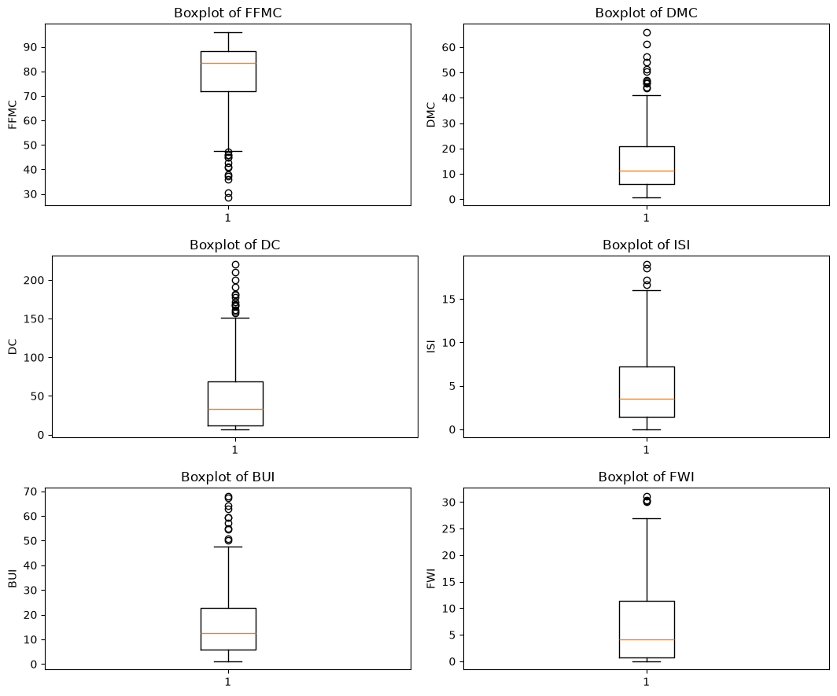
Figure 2. Box plots of the fire-weather indices (FFMC, DMC, DC, ISI, BUI, FWI).
No outliers were removed. The extreme values are not recording errors, since all lie within valid ranges. They represent genuine dry, windy or rainy conditions, and the high-risk tail is exactly the signal that a fire-prediction model needs. With only 243 records, deleting them would also discard a meaningful share of the informative data.

5.4 Feature distributions
Histograms of all columns (Figure 3) complete the picture of the cleaned data.
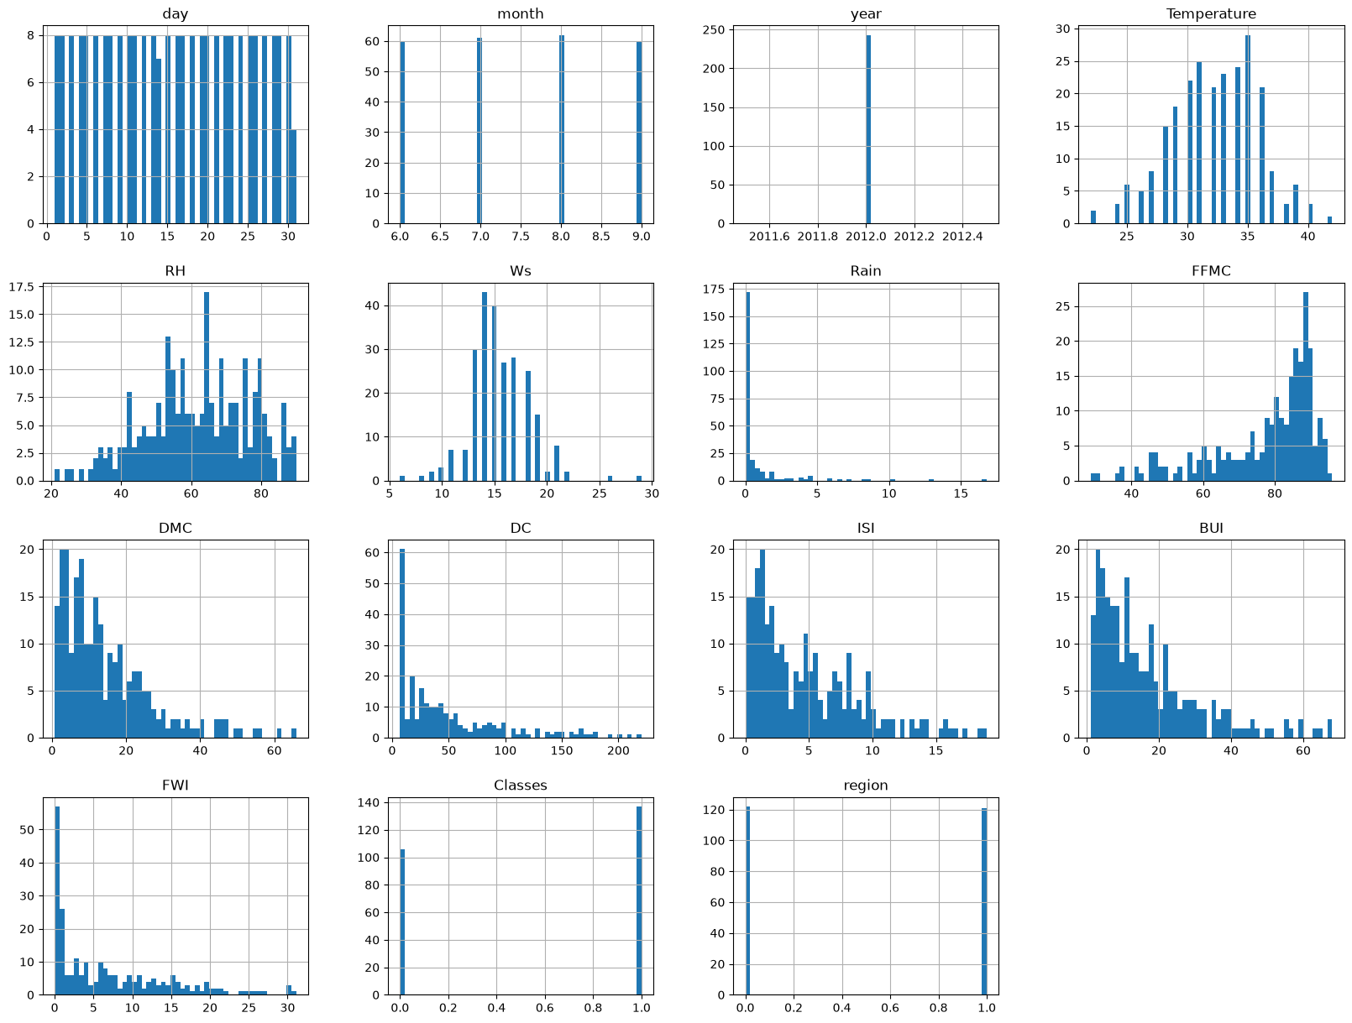
Figure 3. Histograms of all columns in the cleaned dataset (50 bins).
- Balanced coverage. Days are evenly spread, and each of the four months (June to September) contributes about 60 records. The two regions contribute 122 and 121 records.
- Constant column. year takes the single value 2012, so it carries no information.
- Shape of weather variables. Temperature is roughly bell-shaped with most days between 30 and 36 °C; wind speed is concentrated near 14 to 16 km/h; humidity is spread broadly between about 40% and 90%.
- Rain is zero-inflated. Roughly 170 of the 243 days have little or no rain, with a thin tail of heavier rainfall.
- Skew in the indices. FFMC is left-skewed with most values between 80 and 90, while DMC, DC, ISI, BUI and FWI are right-skewed with a spike at the low end.
- Class balance. The target is only mildly imbalanced, with about 137 fire days against 106 not fire days (roughly 56% and 44%, read from the histogram).

6. Observations on the Pipeline
Reviewing the notebook end to end suggests a few points worth addressing before the data is used for modelling.
- The date columns are still in the exported file. The call df.drop(columns=['day','month','year']) is displayed but not assigned back, so clean_dataset.csv still holds all 15 columns and 243 rows. If the date columns are not wanted, assign the result or pass inplace=True.
- Region split is hard-coded. The labelling uses row 122 as the boundary. It works for this file, but locating the title row programmatically (for example by searching for the text "Region") would make the step robust to changes in the file.
- Duplicate check ran before cleaning. Rows that differ only by whitespace or text formatting would not be detected at that stage. Re-running the check on the final data confirms the result.
- Box plots include non-informative columns. Plotting year, region and Classes adds little. The plotting loop also appears twice, once with Seaborn and once with Matplotlib, and one version can be removed.
- Row 168 might be recoverable. Only two of its fields were unreadable. Inspecting the raw text and correcting it manually would keep a valid observation.

7. Recommendations and Next Steps
- Feature selection. Drop year (constant) and decide whether to keep month as a seasonal feature or replace the dates with a day-of-year value.
- Correlation analysis. Plot a correlation heatmap before modelling. In the FWI system, FWI is computed from ISI and BUI, ISI from FFMC and wind speed, and BUI from DMC and DC, so these columns are strongly related. Compare models trained with and without the derived indices to understand how much each contributes and to limit redundancy.
- Skewness. For linear or distance-based models, consider a log1p transform on Rain, DC, DMC, BUI, ISI and FWI. Tree-based models are largely insensitive to this.
- Scaling. Apply StandardScaler or similar for scale-sensitive algorithms, fitted on the training split only to avoid data leakage.
- Splitting and validation. Use a stratified train/test split to preserve the fire/no-fire ratio, and because the dataset is small, prefer cross-validation. Evaluating across regions can also test how well a model generalises.
- Reproducibility. Wrap the steps into a single function or a scikit-learn pipeline so the same cleaning is applied identically to any future data.

8. Conclusion
The preprocessing notebook converts a messy, text-typed CSV with embedded titles and headers into a clean dataset of 243 daily observations with 15 columns, complete numeric types, no missing values and a consistent binary target. The key steps were labelling the two regions, trimming whitespace in names and labels, coercing text to numbers, removing four unusable rows and encoding the class label. Range checks, box plots and histograms showed that the values are physically plausible, that the fire-weather indices and rainfall are strongly right-skewed, and that the classes are only mildly imbalanced. The dataset is ready for exploratory analysis and model building once the small pipeline issues in Section 6 are settled.

